Prcatical No.3
Linux/Windows Network Analysis and ARP Poisoning(Theory and Lab Observations)
Aim:
To perform basic network analysis using Windows and Linux Commands and to understand, at a theoretical level, the concept and security impact of ARP poisoning
Objectives:
- To view and understand IP Configuration and network interfaces.
- To test connectivity using ping.
- To examine active connections using netstat.
- To trace the route taken by packets to a remote host.
- To view the ARP(Address Resolution Protocol).
- To understand what ARP poisoning is, it’s symptoms and impact on.

Requirements:
- One Windows PC with internet/LAN connectivity
- One Linux PC (or virtual machine) with internet/LAN connectivity.
- Command Prompt Access(Windows).
- Terminal Access(Linux).
- Basic Connectivity to a gateway/router or to an external website (e.g. www.google.com).

Very Important safety Note:
Any kind of ARP poisoning or “Man-in-the-Middle” attack must only ever be carried out in a controlled lab environment set up specifically for security demonstrations, and only with proper permission, DO NOT attempt to run.

Section A: Step-by-Step Network Analysis in Windows
Step 1: Open Command Prompt
- Click on the start button.
- Type “cmd” in the search bar.
- Right-click on “Command Prompt” and select “Run as administrator” (if possible).
- A black window (Command Prompt) will open.

Step 2: View Network Interface Details using ipconfig
- In Command Prompt, type: ipconfig /all
- Press Enter
- Observe the following output:
- Host Name
- IPv4 address
- Subnet Mask
- Default Gateway
- Physical address(MAC address)
- Note these values in the observation table.
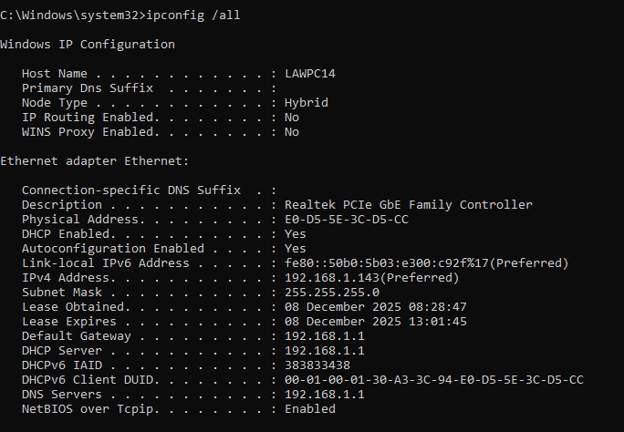

Step 3: Test Connectivity using ping.
- In Command Prompt, type any one of the following commands:
ping 8.8.8.8
ping www.google.com
- Press Enter.
- Observe the output.
- Reply from…. (Successful) or Request timed out (Unsuccessful).
- Time in milliseconds (Average, Minimum, Maximum).
- Note whether the host is reachable (Yes/No).
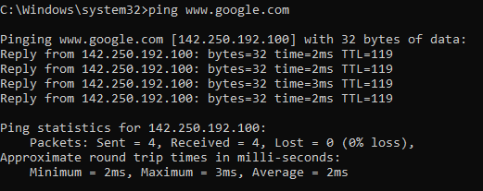
Step 4: View Active Connections using netstat
- In Command Prompt, type:
netstat –an
- Press Enter
- Observe the list of active connections and listening ports.
- Note some sample entries showing:
- Local Address
- Foreign Address
- State(LISTENING, ESTABLISHED, TIME_WAIT, etc.).
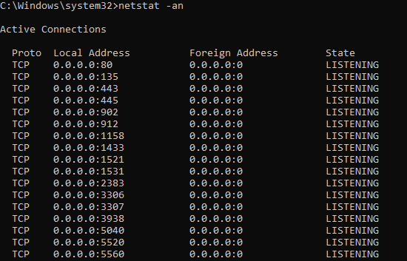
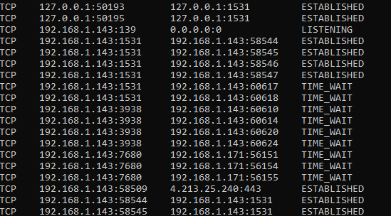

Step 5: Trace Route using tracert
- In Command Prompt, type:
Tracert www.google.com
- Press Enter
- Wait for the command to complete.
- Observe the number of hops and the intermediate routers along the path
- Note the totalnumber of hops in the Observation table.
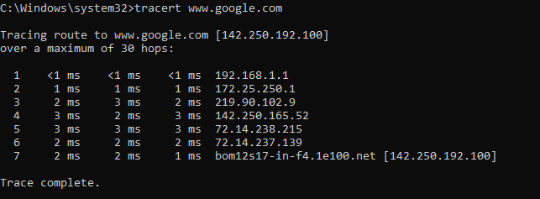
Step 6: View ARP Table using arp –a
- In Command Prompt, type:
arp –a
- Press Enter
- Observe the following in the output.
- Internet Address (IP Address)
- Physical Address (MAC Address)
- Type (dynamic or static)
- These entries show how your system maps IP addresses to MAC addresses on the local network
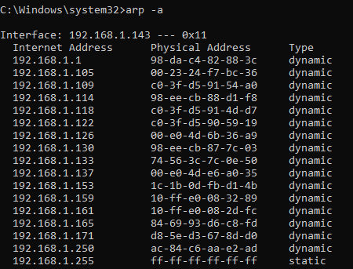

Section B: Step-by-Step Network Analysis in Linux
Step 1: Open Terminal
- Click on the Application Menu
- Navigate to Accessories/System Tools and select “Terminal”
(On many systems, you can also press Ctrl+Alt+T)
Step 2: View Network interface details(ifconfig/ip)
- In Terminal, type:
Ifconfig
(if ifconfig is not available, use: ip addr)
- Press Enter
- Identify your active interface (e.g., eth0,enp0s3, wlan0).
- Note the following for active interface:
- IPv4 address
- Netmask
- MAC address (ether)
Step 3: Test connectivity using ping
- In Terminal, type:
ping -c 4 8.8.8.8
Or
ping -c 4 www.google.com
- Press Enter.
- Observe packet statistics:
- Packets transmitted and recived
- Packet loss percentage
- Round-trip time (min/avg/max)
Step 4: View Active Connections using netstat / ss
- In Terminal, type:
Netstat -tulnp
(If netstat is not available, you can use: ss -tulnp)
- Press Enter.
- Obbserve.
- Listening Ports
- Protocols (TCP/UDP)
- Local & Foreign Addressess.
Step 5: Trace Route using traceroute
- If traceroute is not installed, install it using your package manager.(handled by the lab in advance.)
- In Terminal, type:
Traceroute www.google.com
- Press Enter and observe the intermediate hopes, similar to the Windows tracert command.
Step 6: View ARP Table in Linux
- In Terminal, type any one of the following:
arp -n
or
ip neigh
- Press Enter.
- Observe IP-to-MAC mappings for local network hosts.

Section C: ARP and ARP Poisoning (Concept Only)
- Working of ARP
- ARP (Address Resolution Protocol) is used to map an IP address to a MAC address in a local network
- When a host wants to communicate with another IP in the same network, it brodcasts an ARP Request asking “Who has this IP? Tell me your MAC address.”
- The owner of that IP replies with an ARP Reply containing its MAC address.
- The sender stores this mapping in its ARP cache (which you saw using ARP -a / arp -an / ip neigh).
- What is ARP Poisoning (High-Level Explanation)
- ARP Poisoning (or ARP Spoofing) is a technique where an attacker sends fake ARP replies on the network.
- The goal is to associate the attacker’s MAC address with an IP address of another host (for example, the default gateway).
- As a result, traffic meant for that hosts is mistakenly sent to the attacker first.
- This can allow the attacker to:
- Intercept traffic (Man-in-the-Middle).
- Modify or drop packets.
- Perform further attacks (session hijacking, credential thefts, etc.).
- Observing Symptoms of ARP Issues(Safe Checks)
In a secure lab environment (set up by the instructor), you may be asked to observe the following:
- Unusual or duplicate entries in the ARP cache (same IP address mapped to different MAC addresses)
- Sudden change of the gateway MAC address in the ARP table.
- Intermittent Connectivity or strange routing of traffic.
You can safely check your ARP table using:
Windows: arp -a
Linux: arp -n or ip neigh
- Defensive Measures (Theory)
- Use static ARP entries for critical devices where possible.
- Use managed switches with features like Dynamic ARP Inspection.
- Prefer encrypted protocols (HTTPS, SSH) over plain text ones.
- Use IDS/IPS tools that can detect ARP spoofing activity.
- Regularly monitor ARP tables in sensitive wnvironments.

